
2014 NEW PRODUCTS

Optics

T-Series™ XR Fixed-Power Target Scopes
Weaver’s new T-Series™ XR fixed-power riflescopes combine legendary T-Series target scope performance with an all-new side-focus parallax adjustment system. No matter how far off-center the shooter’s eyepiece-to-eye alignment, the point of impact will remain true. These argon-purged scopes feature the incredibly-precise Micro-Trac® Adjustment system for competition-level, completely independent windage and elevation control with ¹/₈-inch click values. The fully-multicoated optics offer superior contrast, eliminate glare and deliver professional-grade clarity.

Features & Benefits
- Argon-purged tubes to eliminate internal fogging
- Side-focus parallax adjustment
- Include sunshade for clear viewing
- Improved Micro-Trac® erector system for precise adjustment
- ¹/₈-inch click value at 100 yards for competition-level accuracy

Part No. Description UPC MSRP
849940 24x40mm matte, Fine Crosshair ¹/₁₆ MOA dot 0 76683 89940 8 $949.95
849942 36x40mm matte, Fine Crosshair 0 76683 89942 2 $959.95
849944 36x40mm silver, Fine Crosshair 0 76683 89944 6 $999.95
849946 36x40mm matte, Fine Crosshair ¹/₁₆ MOA dot 0 76683 89946 0 $959.95
849948 36x40mm matte, Fine Crosshair ¹/₈ MOA dot 0 76683 89948 4 $959.95
849941 24x40mm silver, Fine Crosshair ¹/₁₆ MOA dot 0 76683 89941 5 $979.95
849985 46x48mm matte, Fine Crosshair ¹/₁₆ MOA dot, 30mm 0 76683 89985 9 $1,399.95
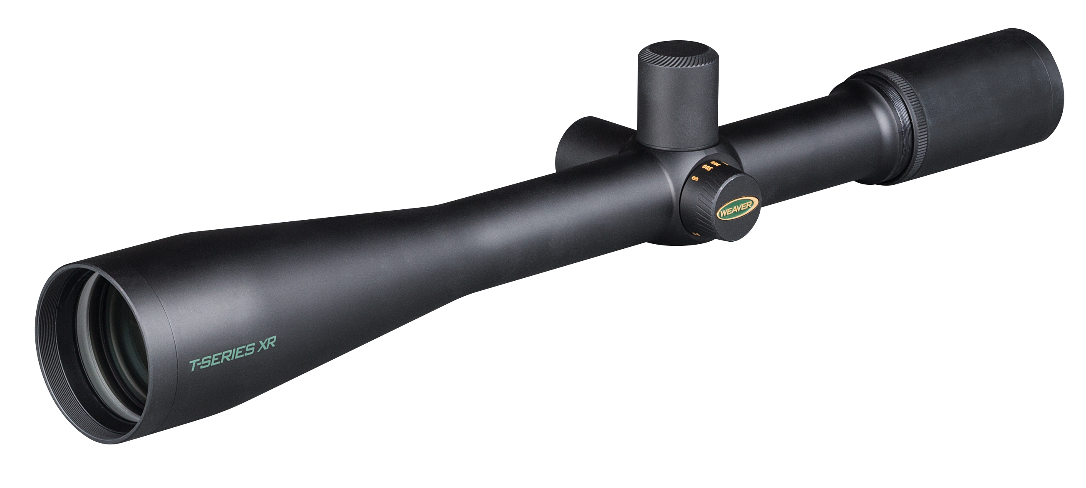
849987 46x48mm matte, Fine Crosshair, 30mm 0 76683 89987 3 $1,399.95

